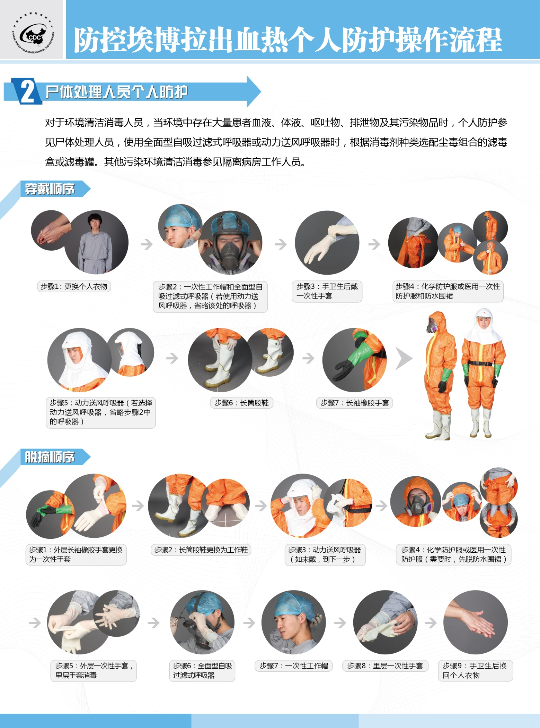**7.**[**尸体处理人员个人防护**](http://www.chinacdc.cn/jkzt/crb/ablcxr/zstd_6242/201409/W020140915371744302532.jpg)

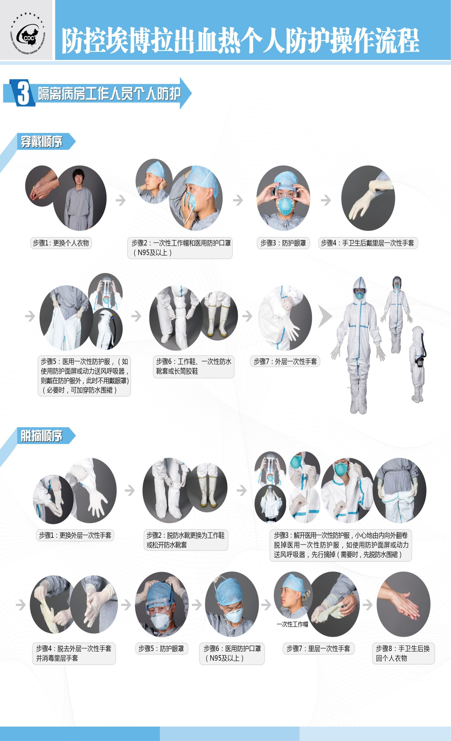**8.**[**隔离病房工作人员个人防护**](http://www.chinacdc.cn/jkzt/crb/ablcxr/zstd_6242/201409/W020140915371744411977.jpg)

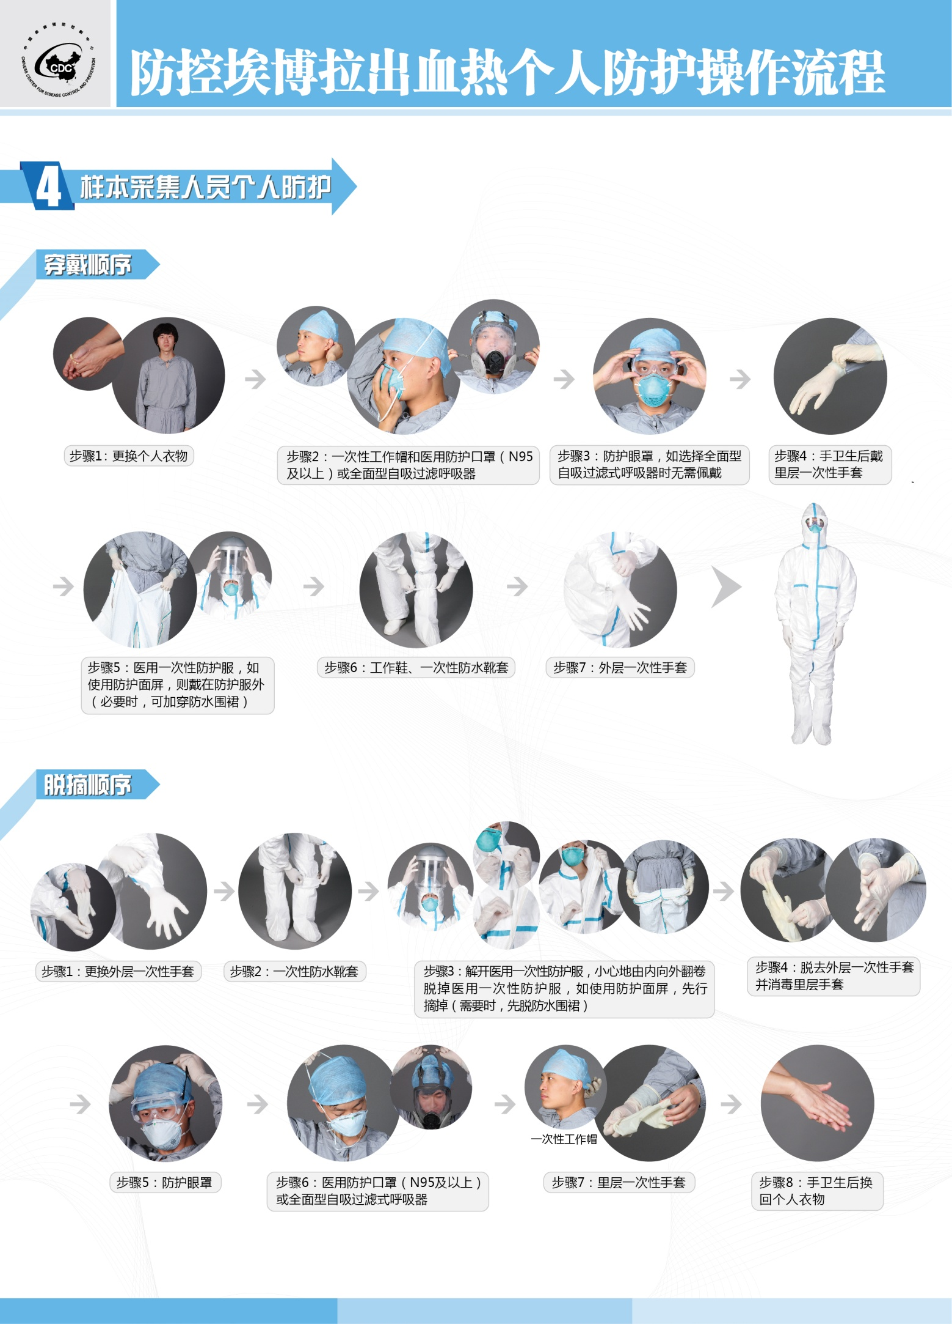**9**[**.样本采集人员个人防护**](http://www.chinacdc.cn/jkzt/crb/ablcxr/zstd_6242/201409/W020140915371744524864.jpg)